Learning Ally Story Teller Course Evaluation
Evaluation Team: F4
Rebecca Dethlefs, Ben Fowler, John Tong, Deborah Tonks
University of Georgia - EDIT7350E
Rev: 3/17/2019
Learning Ally Story Teller Course Evaluation
1. Introduction and Background (1 Point)
Client Background
Learning Ally is a national non-profit organization that creates, maintains and provides high quality human-read audio books in support students with learning difficulties. Learning Ally also provides resources such as lesson plans and support communities for schools with struggling readers, individual home readers who are diagnosed with blindness, vision deficit, dyslexia or other learning disabilities. The production of the audiobooks is handled by a cadre of volunteers across the country.
Online classes are available to help facilitate the onboarding of volunteers for several of the job categories. Roles needed are narrators to read the books and listeners to check for accuracy, content or quality. Our group will be evaluating the Storyteller Course. The Storyteller Course is the eLearning course for volunteer narrators who will help create juvenile fiction audio books. It is composed of 4 different ‘lessons.’
- The first lesson is about narration. After completion, the volunteer submits an audio recording to judge vocal tone and ability before being allowed to proceed to the rest of the course.
- The second lesson is about setting up a recording studio, both in terms of hardware and equipment required as well as software.
- The third lesson is about the Literature Portal which is used to find an audition for a project, as well as communicate about the project between project coordinators and the volunteer.
- The fourth lesson is setting up a volunteer narrator profile that covers specialties, special skills or special knowledge that might help casting for certain projects.
The client is Eleanor Cotton, Learning Ally Director of Production Technology and Training. We have been in communication with her on the needs of the organization as well as any insight she may have on the evaluation project. Our goal is to be able to provide helpful and actionable insights that will help Learning Ally as well as the volunteers taking the course.
Evaluation Team
Our evaluation team includes four professionals who are highly skilled in Instructional Design and have a desire to help clients improve eLearning courses through this evaluation. The knowledge pool of this team in eLearning compliments the needs of this evaluation specifically since it is an online learning course. Learning Ally’s courses train volunteers to produce and edit high quality audio books. We have members that will help us to help Learning Ally reach that goal. In working towards that end we have one team member that has experience in audio recording, one who has a background in education, one who helps design classrooms incorporating learning needs of all abilities and one who can help us to pull all our statistical information together for the client presentation.
Rebecca Dethlefs currently holds the position of Academic Advisor at Athens Technical College in Athens, GA. She received her B.S. Ed in Elementary Education and is currently enrolled in the Master of Instructional Design and Development at the University of Georgia. Rebecca brings stellar writing, editing and evaluation skills to our evaluation team, as well as experience using Articulate Storyline 360, Adobe Creative Cloud Suite and Photoshop.
Ben Fowler is currently in graduate school at the University of Georgia and serves as a Graduate Teaching Assistant for the Warnell School of Forestry and Natural Resources as well as a Graduate Assistant to the Outdoor Recreation program at the Ramsey Student Center. He received his B.A. in Spanish and Biology from UNC - Asheville and is a candidate for a M.S from the University of Georgia in Natural Resources, Recreation, and Tourism. Before attending graduate school, Ben was the Stewardship Director of the Georgia Conservancy. Ben’s areas of expertise on our team are in statistics and software such as Microsoft Office, SPSS and ArcGIS.
John Tong is an Application Analyst Principle for the Student Information Systems Team at the University of Georgia (UGA). He received his B.SCS from Georgia Technical Institute as well as Certificates in Organizational Management and Environmental Toxicology. At UGA he has done some graduate course work with Databases and Data Science and is currently pursuing an eLearning Design Certificate. John brings strong technical and organizational skills to our evaluation team with areas of expertise including: technical documentation, presenting, Cast Member in several podcasts, Photoshop and Audacity.
Deborah Tonks is currently an IT Manager for Instructional Technology at the University of Georgia. She is a graduate from the University of Georgia with a degree in Computer Science and is currently working towards a Master’s Degree in Instructional Design and Development. Deborah has worked with multiple LMS platforms and is currently serving as a campus administrator for Brightspace (D2L). Strengths brought to the evaluation team include Articulate Storyline 3, Adobe Creative Cloud Suite, Photoshop and a certificate in Project Management.
2. Evaluation Purpose (1 Point)
Evaluation Purpose
Our Evaluation Team will be assessing an educational technology program administered by Learning Ally, a nonprofit organization offering education solutions to over 16,000 schools. The course , called Storyteller, provides training to volunteers on how to become audiobook narrators and is focused on young adult fiction. Since Learning Ally relies on volunteers for recording, those taking the course could drop out or leave the program at any point. Our evaluation team will analyze data to see what constraints exist as possible barriers to completing the course as well as identify factors that influence successful course completion. To do this we will focus on three main objectives centered on obtaining feedback from actual volunteers who have gone through the course. Once problem areas have been identified, we will offer a suggested approach to Learning Ally on possible solutions to improving graduation rates and enhancing the training lessons.

Objectives
- Assess how prepared the Storyteller course graduates felt upon graduation.
- Identify the areas that the graduates felt should be included in the Storyteller course once they started volunteering.
- Identify areas that are impeding the graduation rate of the Storyteller course.

3. Stakeholders (1 Point)
Table 1. Stakeholder Information
Stakeholder | Importance Level | Perspective of Interest | Role in the Evaluation
1. Learning Ally Volunteers (Who take the course and eventually volunteer to record) | Primary | Effectiveness of the learning | Interviewee
2. Learning Ally Software Design Team | Primary | Usability and Effectiveness of the eLearning course | Interviewee and recipient of the evaluation report
3.Literature community staff who approve auditions, manage volunteers and projects, and ensure audio and audiobook quality. | Secondary | Effectiveness of the eLearning program on learning | Interviewee and recipient of the evaluation report
4. Learning Ally members (the ultimate consumers of the audiobooks) but it may be difficult to survey them | Secondary | Usability of the eLearning program | Interviewee

4. Logic Model (3 Points)
Table 2. A Simplified Logic Model in a Table Form
Context:
Amount of time the learners have to devote to the training
Computer resources and availability
Computer skills and expertise
Learner’s ability to self-evaluate and self-pace
Education level
Technology aptitude
Limitation and difficulty navigation Moodle
Availability of appropriate recording equipment
Availability of appropriate recording space

Population and Needs:
Training on how to create a recording space.
Knowledge of how to find, communicate about, and audition for projects. (lesson 3)
Training in recording audio books
Training on how to complete initial post production editing of audio recordings.
Use of Learning Ally software, Easy Books
Training in how to create audiobooks that are engaging and accurate

Age and Phase:
The Storyteller course has been implemented and has been in use since January 2, 2019.
Resources/Inputs | Activities | Outputs | Short-Term Outcomes | Long-Term Outcomes
Money comes from institutional and individual subscriptions to LA  EPC, Instructional designer  Moodle LMS,  LA website,  Google Hangout,  LA staff,  LA literature community | LA expanded its training program  Development of ST course  Announcement of ST course  LA volunteers submitted a voice audition and completed the ST training | Trained LA volunteers able to produce interesting, well-read, audibly engaging, complete  audio books | Creation of complete audiobooks.  Donation of time and skills by LA volunteers.  Audio style will be more consistent and of higher quality across all juvenile fiction audio produced by completers of this course. | Access to literature by learners who cannot access or use print books.  Sense of accomplishment and service for LA volunteers.  The use of eLearning provided broader accessibility to a larger number of volunteers compared to the in person and in studio prior model.  Volume of volunteers that can be trained is much greater and the cost per volunteer trained is greatly decreased.  The total volume of completed audio books is anticipated to increase.

Summary of Table
The Storyteller course was implemented and has been in use since January 2, 2019. The effectiveness and implementation of the Storyteller course may be influenced by the several factors. The amount of time the learners have to devote to the training may cause the learners to rush through it. Or if their available time is very limited, they will not be trained to narrate audiobooks quickly enough to keep up with demand for the completed books. Learners must also have access to and availability of computer resources for the training. They must have sufficient computer skills and expertise to use eLearning for the training and be able to self-pace and self-evaluate as they progress through the Storyteller course. Education level, comfort level with technology, and the limitations and difficulties of navigating Moodle may also be hindrances.
Learners must either purchase or have available appropriate recording equipment and be able to complete the voice audition in a quiet space with extraneous sounds
Resources/Inputs include funds from Learning Ally, the Instructional designer, Moodle LMS, a Google Hangout for easily accessible communication, the Learning Ally staff, and the Learning Ally literature community. Activities performed were the expansion of the training program, development of the Storyteller course, announcement of the course, submission of a voice audition, and completion of the Storyteller training. This resulted in trained volunteers able to produce interesting, well-read, audibly engaging, and complete audiobooks. Short term outcomes include creation of complete audiobooks and donation of time, skills and use of computer and recording resources by the volunteers. In the long term, this provides access to literature for learners who cannot access or have difficulty using print books and gives a sense of accomplishment and service for the volunteers.

The Storyteller course was created to train Learning Ally volunteers to create a recording space, to record audiobooks, to edit the audio books they create, to use Easy Books (Learning Ally software), and to produce audiobooks that are engaging and accurate. It also teaches them how to find, communicate about, and audition for recording projects.

5. Evaluation Questions (3 Points)
Table 3. Focus Areas, Questions, Design, and Rationale of Your Evaluation
Stakeholder | Stakeholder Needs | Evaluation Focus Areas | 3-5 Evaluation Questions | Evaluation Design | Evaluation Design Rationale
1. Learning Ally Design Team | That instruction be effective, efficient, and learners be prepared to complete recordings. | Outcome and output activity. (Course completion, and eventually project completion)  The listeners that use Storyteller might not be available for our team to survey. | -How effective would you say the course was in preparing you for future recordings?  -Are there certain aspects of the course you found to be lacking in resources and guidance? What improvements would you suggest?  -Which aspect of the training program has received the most confusion by volunteers? | Outcome Mapping, Quantitative and Qualitative interviews. | Outcome Mapping was chosen for this evaluation. Storyteller is a course that has already been completed by Learning Ally staff and volunteers. This evaluation will be used to help the client understand how it influences those that interact with the course. In this case the Learning Ally volunteers. For this evaluation the learners will complete surveys and in some cases interviews to determine what behaviors and actions have changed in the learner to help decide if the course if meeting the desired goal. By collecting qualitative and quantitative data, through interviews and surveys, we will be able to get numerical data as well as observations from the stakeholder.

6. Logistics and Timeline ( 1 Point)
The team is creating and will administer surveys to the Literature Community: LA staff, volunteers(narrators) and members (users of the audiobooks) using Survey Monkey. Interviews of Learning Ally Course Developers and Learning Ally members (if accessible) will be conducted.
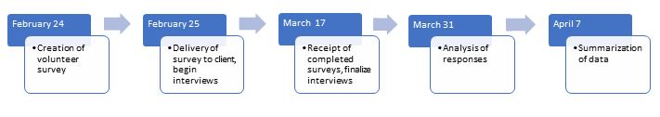
Task | Team Member | Start date | End date
Creation of volunteer survey | all | 2/25 | 3/10
Load into Survey Monkey | Becky | 3/10 | 3/12
Deliver survey to client | Deb | 3/12 | 3/12
Schedule interviews | Becky | 3/04 | 3/18
Hold interviews | All | 3/04 | 4/01
Receipt of completed surveys | Deb | 3/17 | 4/01
Analysis of responses | All | 4/01 | 4/08
Summarize data | John | 3/17 | 4/08
Summarize data from Moodle | Ben | 3/17 | 4/01
Reporting of data | John | 3/17 | 4/14

7. Limitations (10 Points)
There are four main limitations that the F4 Evaluation Team encountered in the Storyteller Course Evaluation.

Limitations:
- Limited time frame to complete the evaluation
- No feasible way to follow up on long term goals
- No obligation for surveyed volunteers to respond
- Inability to contact or survey those who did not complete the training

This evaluation was done as part of a project for a graduate course and as such introduced limitations specific to that situation. The first two limitations are a direct result of this structure. The semester end date is the end of the teams ability to conduct further data gathering and analysis. Not only must all data be collected, analyzed, and returned to the client, but there is also no time for follow up to see if the any suggested changes were made, and if so, if they were successful. These limitations allow for practice of evaluation but not for follow through.
The third limitation identified was that the people that we requested data from are volunteers. When volunteers are the main source of data, they cannot be required to respond. Responses were received from 17 of the learners after sending out the survey twice. Those responses supplied us with a good set of data from which to draw our conclusions, but this area of our evaluation was beyond our control. If no one had responded there would not have been any data.
The final limitation that made a big impact on our evaluation was the inability to survey or talk to those that did not complete the course. The third project objective was to identify areas that are impeding the graduation rate. The best way to determine that would be to interview those who did not finish. The client did provide our team with data that identified the point in the course where a Storyteller volunteer was most likely to stop. The data was very coarse grained, so further analysis of the LMS to see what sections of each lesson that was completed may provide further insight.

8. Data Collection and Analysis Plan (20 Points)
The evaluation team deployed a mixed-methods design approach (qualitative/quantitative) to gain insight into improving the Storyteller course. Through survey questionnaires administered via Survey Monkey using Likert Scale measurements, quantitative methods were used to address volunteer perceptions and attitudes regarding the Storyteller course. Additionally, several qualitative and binary (yes, no) questions were asked of the volunteers to gain further insight into the effectiveness and problem areas of the course. Unfortunately, after discussion with the client, interviews with graduates or staff were not possible in the scope of this project. It was decided to add open comment sections to all the questions in an attempt to capture some of that type of feedback.

Table 4. Storyteller graduate survey (administered via Survey Monkey)
Evaluation Questions | Data Collection Method | Data Source | Activities | Data Analysis
1.How effective was the course in preparing you to create audiobooks? | Survey; Quantitative; Single Likert Item 5-point Scale | Storyteller Course Graduates | Survey Designed,  Approved by client,  Sent to graduates, Data collected | Thematic Analysis was used throughout the survey analysis. It was used to identify patterns within the data collected.
2. How effective was Lesson one: Course Introduction, Expectations, Art of Audiobook Narration, and Voice Test in preparing you to narrate audiobooks for Learning Ally? | Survey; Quantitative; Single Likert Item 5-point Scale | Storyteller Course Graduates | Survey Designed,  Approved by client,  Sent to graduates, Data collected | Thematic Analysis was used throughout the survey analysis. It was used to identify patterns within the data collected.
3. How effective was Lesson two: Set Up and Environment in preparing you to set-up a recording space? | Survey; Quantitative; Single Likert Item 5-point Scale | Storyteller Course Graduates | Survey Designed,  Approved by client,  Sent to graduates, Data collected | Thematic Analysis was used throughout the survey analysis. It was used to identify patterns within the data collected.
4. How effective was Lesson three: Literature Portal in preparing you to navigate the Literature Portal? | Survey; Quantitative; Single Likert Item 5-point Scale | Storyteller Course Graduates | Survey Designed,  Approved by client,  Sent to graduates, Data collected | Thematic Analysis was used throughout the survey analysis. It was used to identify patterns within the data collected.
5. Are there certain aspects of the course you found to be lacking in resources and guidance? What improvements would you suggest? | Survey;  Yes/No response with comment area. | Storyteller Course Graduates | Survey Designed,  Approved by client,  Sent to graduates, Data collected | Thematic Analysis was used throughout the survey analysis. It was used to identify patterns within the data collected.
6. Please estimate how long it took you to complete the course and did you do it all in one sitting? If not, how many sessions did it take? | Survey; Qualitative; Short Answer response | Storyteller Course Graduates | Survey Designed,  Approved by client,  Sent to graduates, Data collected | Thematic Analysis was used throughout the survey analysis. It was used to identify patterns within the data collected.
7. What motivated you to enroll in the Storyteller course? Are you an aspiring audiobook narrator, voiceover artist, teacher or parent of a struggling learner, etc.? | Survey;  Qualitative;  Short Answer | Storyteller Course Graduates | Survey Designed,  Approved by client,  Sent to graduates, Data collected | Thematic Analysis was used throughout the survey analysis. It was used to identify patterns within the data collected.
8. If you have started volunteering, have you encountered challenges that  we could have better prepared you for? | Survey;  Quantitative and  Qualitative;  Yes/No response with comment area | Storyteller Course Graduates | Survey Designed,  Approved by client,  Sent to graduates, Data collected | Thematic Analysis was used throughout the survey analysis. It was used to identify patterns within the data collected.
9. Before this course, I’d rate my narration/audio recording skills as … | Survey;  Quantitative and Qualitative;  4 point Likert scale with comment section | Storyteller Course Graduates | Survey Designed,  Approved by client,  Sent to graduates, Data collected | Thematic Analysis was used throughout the survey analysis. It was used to identify patterns within the data collected.
10. After this course, I’d rate my narration/audio recording skills as … | Survey;  Quantitative and Qualitative;  4 point Likert scale with comment section | Storyteller Course Graduates | Survey Designed,  Approved by client,  Sent to graduates, Data collected | Thematic Analysis was used throughout the survey analysis. It was used to identify patterns within the data collected.

9. Result (20 Points)
A summary of the results of the survey data are presented below. The raw data of our evaluation questions is attached as Appendix B along with comments from the respondents.

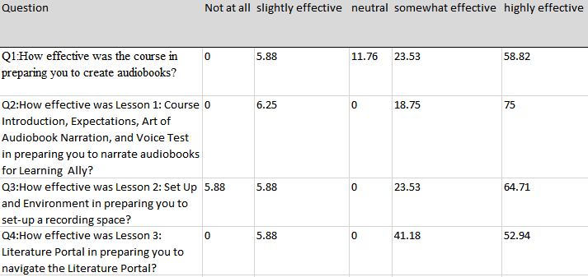
Table 5: Initial raw results of the 5 point Likert quantitative data assessing effectiveness of the course as a whole as well as the effectiveness of individual lessons. (from Survey)

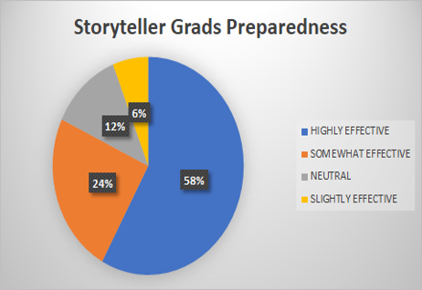

Figure 1: Displays the sentiment of respondents on the effectiveness of the training on their preparedness for volunteering. (from Survey)
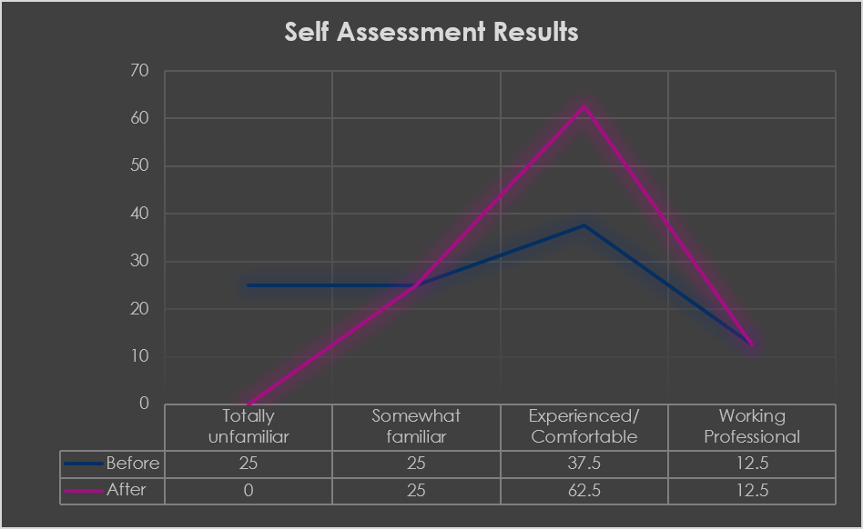

Figure 2: Displays Pre and Post course self assessment of how comfortable volunteers felt in narrating and recording audiobooks. Numbers are in percent. (from Survey)

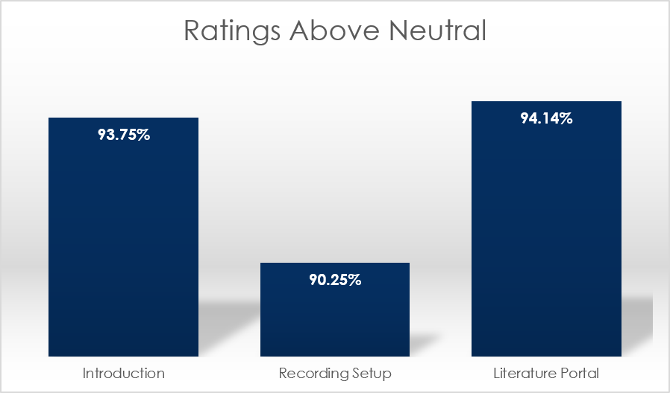

Figure 3: Percentage of respondents that rated individual lessons above Neutral. (from Survey)
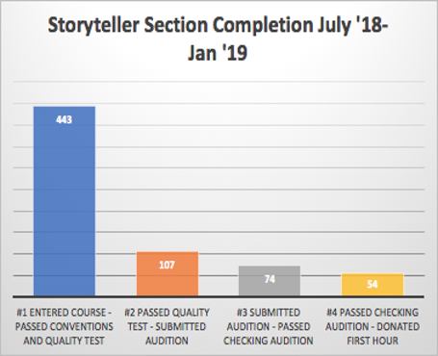
Figure 4: Data provided by Learning Ally on Storyteller volunteer completion pipeline about the six months prior to launch (provided by client)

9. Discussion (20 Points)
Objective 1: Assess how prepared the Storyteller course graduates felt upon graduation
The first objective was to assess how well the graduates felt the Storyteller course prepared them for their volunteer work narrating and recording audiobooks. Question 1 of the assessment was included for an overall impression from the volunteer. Questions 9 and 10 provided a post course self-assessment of their abilities before and after taking the course. Questions 2 - 4 provided some insight into the individual lessons of the course. Combined, these questions provide an overall view of how the volunteers felt they progressed.
As an overall measure, 82% felt that the course was effective at preparing them for their volunteer work. The post course self-assessment showed that 100% of the respondents felt at least some familiarity with the process and 85% reporting comfort with recording. The pre and post skill self assessment showed that 25% of the respondents were completely unfamiliar with the material before the course and none were by the end. It also showed that the Comfortable category increased from 37.5% to 62.5%. As noted by several of the respondents, practice and use of the skills is what it would take to be fully comfortable, but after the course they felt “confident enough to go ahead.” Additionally, there was a population that categorized themselves as experienced narrators or professionals and did not show a change from the pre/post assessment.
As for the individual courses, all rated very well with the individual lessons rating 93.5%, 90.25% and 94.14% above average. The lowest rated one was Lesson 2, the setting up of the home studio. There were several reports of issues in that section as well as general responses that they required troubleshooting assistance, or that there was insufficient information provided.
It should be noted that these numbers are for a very small population of the overall volunteer community with only 17 respondents. The feedback over several months should be accumulated to decide on what the best use of limited resources for creating improvements should be.

Objective 2: Identify the areas that the graduates felt should be included in the Storyteller course once they started volunteering.

This objective was intended to help identify areas of the course that could be improved in terms of content or presentations that would help volunteers perform their duties more effectively to further the Learning Ally mission. Questions on the individual chapters, questions 2 through 4, allow for general comments and Question 5 and Question 8 directly addresses this objective.
Out of the individual lessons we found that respondents could use some additional support of various types for the different areas. For the setup of the studio, a FAQ document for common troubleshooting might be useful for those trying to iron out issues in their setup. In the Easybooks lesson, job aids might be helpful for specific tasks like recording and common editing corrections. A reference document is available but may be daunting for beginning users. Further discussion of these requests and benefits are covered in the Recommendations section of this document.
The assessment was issued to a population that had recently completed the course. As such, this objective would benefit from a longer term follow up that is outside the scope of this study. One respondent warned that they had not yet done their first recording and another commented that they just completed their first recording and had not yet even received feedback yet. The perspective of the graduates after they complete their first project or two would be invaluable, and a follow up should be considered for feedback at that point. Also, as noted in Objective 1 discussion, our respondent population is still small. Collecting feedback over time should clarify if these requests are recurring and would provide a good return on time invested.

Objective 3: Identify areas that are impeding the graduation rate of the Storyteller course.

The third objective focuses on trying to identify ways of increasing the graduation rate of the volunteers that begin he course. We understand that there is a large attrition rate from those that enter the course to those that complete the course and submit an audition. Our research team was hoping to identify some of the factors that might help influence the completion rate. We were able to use much of the information gathered from the previous objective questions to begin this analysis.
Some of the suggestions included a fast track for experienced and current readers. This would help those that are motivated to create a few narratives as a break from nonfiction and increase novelty. Another is providing written reference materials for each of the chapters as opposed to the primarily video course. These same materials can be made as job aids that can be referred to for common tasks on both the portal as well as in Easybooks to help volunteers and address a second need we encountered which we discuss in the General Observations section of this paper.
On the surface it seemed like a straight forward objective and plan. Query the graduates, identify difficulties that they encountered, and address those to improve the completion rate. We can address these, but found that there were many suggestions for improvements that would assist the operations and the volunteers that had completed the course. Upon further reflection we believe that the best source of that kind of data may be a short questionnaire for those that started but have not completed the course yet. Mining the LMS serving the lesson information may also help highlight the lessons where the most people stop progressing, though the context or cause for the stop would not be as easily determined as from a direct questionnaire.

General observations
We found that in querying about feedback to improve the course that we came across several suggestions for assisting the volunteers with their continued work. These suggestions could be used to help with retention, performance, and reducing the friction of those returning to recording after a break. They seem to be requesting supplemental documentation that would act as a handbook. Things like FAQ for troubleshooting equipment, how to perform specific volunteer activities such as tracking time or using the software for specific tasks. Some are even looking to improve their narration skills and were looking for tips such as suggestions on improving reading in different voices. There are links to other resources within some of the lessons, such as links to equipment in the equipment lesson, but there was not one visible on the course site itself nor was there one that we saw that could act as a handbook.
We received feedback that was much more detailed than was expected in the motivation question. The responses opened entirely different avenues to pursue to increase
retention and completion. One idea inspired by the responses that might help retention is to include a short section early in the lessons about the volunteer site and available resources there to get socially engaged.
Another idea relating to this is to take a common practice in many other information businesses and have an autoresponder contact script that gently encourages completion of the course or congratulates them on progress. A separate autoresponder script might welcome volunteers back after a break since their last volunteering along with helpful job aids such as “finding a project on the portal,” “auditioning,” or “time tracking.” These are proven tools in the business sector and could easily be applied here for positive reinforcement.

11.Recommendations (20 Points)
General Recommendations:
- Administer continued surveys for graduates to improve the confidence in the results. Our current response set was good for initial analysis. However before limited Learning Ally resources are spent continued surveys should be conducted and results aggregated over time.
- To address the limitations of the second objective, a follow up survey can be performed after the first project or two has been successfully reviewed, edited and accepted.
- To address the limitations of the third objective, a brief survey of non-completers within a month should be considered. There are probably a good number of hypothesis on why there is such a high attrition rate, such as “don’t have enough time” but it would be useful to get confirmation and perhaps there are situations that can be addressed.

Completion Recommendations, these recommendations focus on improving completion rates of the class.
- Consider a fast track for professional or current Text book readers. Though they are both different kinds of narration, it would reduce the barrier of crossing over and allow readers of one type to dabble in the other for a change of pace.
- Include a brief introduction to the Volunteer resources and perhaps social aspects such as a FB group or Twitter feed that can contain both social as well as technical articles.
- Consider the use of an autoresponder script to help with situations such as encouraging completion and helping returning volunteers offering resources that could be helpful.
- Respondents seem to be interested in more supplemental reading material, in specific written material, perhaps those individuals are not visual and did not respond well to the highly interactive multimedia classes. Additional survey data over time can confirm if this is a trend.

Support Recommendations: These are not directly addressing our primary objectives, but are recommendations based on the results and observations. They primarily revolve around supporting existing volunteers in their work. These specific innovations were requested by respondents, but as above, additional surveys can see if these job aids might be a long term value.
- Job aids for common Audio editing tasks using Easy books. Currently there is a video lesson and a comprehensive reference document. A focused resource on some of the most common correction recommendations might be helpful
- Job aids for Literature Portal. This was also cited as the site has a lot of functionality and returning volunteers after a while may find it easier to get back into recording with a few tips.

Carrying out an evaluation of Learning Ally’s Storyteller course was a positive learning experience for the team members. Experience with formal evaluation varied among members, but each person contributed skills that caused the team to function well. It was gratifying to serve a non-profit organization and it is the hope of the team that it contributes to their continued success and help them to better serve their stakeholders.

Appendix A:

Survey:

1. How effective was the course in preparing you to create audiobooks?
2. How effective was Lesson 1: Course Introduction, Expectations, Art of Audiobook Narration, and Voice Test in preparing you to narrate audiobooks for Learning Ally?
3. How effective was Lesson 2: Set Up and Environment in preparing you to set-up a recording space?
4. How effective was Lesson 3: Literature Portal in preparing you to navigate the Literature Portal?
5. Are there certain aspects of the course you found to be lacking in resources and guidance? What improvements would you suggest? [Open answer]
6. Please estimate how long it took you to complete the course and did you do it all in one sitting? If not, how many sessions did it take? [Open answer]
7. What motivated you to enroll in the Storyteller course? Are you an aspiring audiobook narrator, voiceover artist, teacher or parent of a struggling learner, etc.? [Open answer]
8. If you have started volunteering, have you encountered challenges that we could have better prepared you for? [Open answer]
9. Before this course, I’d rate my narration/audio recording skills as: [4 pt scale]
10. After this course, I’d rate my narration/audio recording skills as: [4 pt scale]

Each of these comes with a selection on a 5 pt scale unless noted otherwise. Also, there is an additional comment box available for each question.

Proposed additional interview questions pool:
What motivated you to enroll in the Storyteller course?
Are there certain aspects of the course you found to be lacking in resources or guidance?
Did you have any difficulty completing any of the lessons?
Did the lessons hold your interest?
Please describe your pacing as you progressed through the lessons.
Do you have any further suggestions for improvement?

Appendix B:
Final survey integrated open answer comment boxes for each question as interviews were not possible after discussion with the client. Questions and results, along with respondent answers are as below.

Q1 How effective was the course in preparing you to create audiobooks?
Not at all slightly effective neutral somewhat effective highly effective
0 5.88 11.76 23.53 58.82
- "Well, I feel like it was, anyway--I've just recorded my first little book, but haven't received feedback yet, so I guess in a way the jury is still out. ;-) 2. "
- "I've been reading for Learning Ally for 12 years, so much of the material was not new."
- "I am more of a hands-on learner, so it would have been better for me to be able to try out some of the things mentioned as I go through the training. Also, it would be nice to be able to easily refer to instructions later on, when I need them - I feel that video isn't always the best way to do this. I think I did find a summary of the process after I went through the training, but it might be helpful to mention this and its location, with a clickable link, in the training."
- Video from the woman who works with audio books was extremely informative. I took both the storyteller course and the other one and I think they are both needed to properly prepare you to record.
- "The Storytelling Course did a good job, however as I had already done the textbook training course and then logged many hours recording textbook files, needing to then take the full Storytelling Course was a bit redundant. "
Q2 "How effective was Lesson 1: Course Introduction, Expectations, Art of Audiobook Narration, and Voice Test in preparing you to narrate audiobooks for Learning Ally?"
Not at all slightly effective neutral somewhat effective highly effective
0 6.25 0 18.75 75
- I thought the LOC video was especially helpful. I've watched it a couple of times. I had a problem navigating how to submit my first audition. For me it was not clear and I believe I needed Chrome.
Q3 How effective was Lesson 2: Set Up and Environment in preparing you to set-up a recording space?
Not at all slightly effective neutral somewhat effective highly effective
5.88 5.88 0 23.53 64.71
- "I still needed help setting up the microphone (to set the gain, etc). Some tips on the common setup would be good to add."
- I had a little trouble setting up my environment. I kept getting a humming noise. It was hard to figure out why.
- "I have had a good deal of experience with recording, so I didn't need this lesson. "
- No new info for me here since I've been recording textbooks for Learning Ally for many years. Eleanor voice is great.
Q4 How effective was Lesson 3: Literature Portal in preparing you to navigate the Literature Portal?
Not at all slightly effective neutral somewhat effective highly effective
0 5.88 0 41.18 52.94
- I would have like to be able to move the player back and forth to view different parts of the video instead of being forced to restart it from the beginning
- "Again, more helpful to be able to try out some of it during the training. "
- SO much info. I was afraid is forget some of it. But it is easy to navigate back into it to get a refresher as I got myself started after 'graduating'.
Q5 Are there certain aspects of the course you found to be lacking in resources and guidance? What improvements would you suggest?
No Yes 62.5 37.5
- "Perhaps an after course reference sheet, for after we pass the course but haven’t engraved the recording steps into our brain."
- "Not really, but I'm guessing that as I get further into this activity, I'll find some things (it's been like that with every training I've ever taken in my life; I have no reason to expect it to be different here). Ask me again in a month or two."
- "Reviewing the guidelines for reading literature would be good. The video before the course starts is good, but adding some of those tips to the course would be good."
- So much detailed instruction...hard to remember some of it. I'm not super computer literate so would appreciate material...in writing...that I could download and refer to.
- It would be more effective to allow experienced volunteers to skip the introductory sessions.
- "Lesson 3-2 explains how to audition for a book project. However, if you need to re-submit an audition, there are no instructions on how to do this. Including information about which errors can be edited out in post-production versus needing re-recording."
- "Just how to submit my first voice test. However, as always, staff was very helpful."
- "As above, I would have the content from the other course be included in this one as well."
- "I think the guide to conventions could be improved. Or exercises created to walk through ""case studies."""

Q6 "Please estimate how long it took you to complete the course and did you do it all in one sitting? If not, how many sessions did it take?"
3 or 4 sessions over the course of a week.
- "I work long hours as a college instructor so it took me several sessions as I kept having to repeat material. I think I did it in three or four sessions, but I can't remember. I probably could have done it in one sitting, but I'm not sure I would have retained much."
- 1 session up to the audition 2 sessions more.
- About 4-5 hours overall. I did it in several sessions.
- I think I did it in 2 sessions--maybe an hour in all.
- 4 hours? 3 or 4 sessions 2 sessions about 30 minutes each
- I did it in multiple session due to my own limited time constraints the program difficulty was not a factor.
- "about two hours in two sessions, one hour each"
- 3 days
- "It probably took about an hour. However, I did go back several times to certain areas as a review "
- "As I recall, I completed it in 3 sessions. I repeated parts of some sessions because I feared I would forget some of the material about getting into and navigating the portal. I appreciate the interactive ""click on the xxxx tab"" even though it was basic."
- I don't remember how long it took. I did the course many weeks ago.
- 1.5 hours. I did it in two sessions
- "It needed to take 2 sessions to complete the course. Life would not allow me to do it in one session, it's too busy."
- 2 or 3
- 1 hour
Q7 "What motivated you to enroll in the Storyteller course? Are you an aspiring audiobook narrator, voiceover artist, teacher or parent of a struggling learner, etc.?
- I used to volunteer at an RFBD studio a number of years ago and enjoyed it.
- I am a voiceover artist who likes to give back.
- aspiring narrator
- "I've just always loved reading aloud, and was really drawn to the idea of doing it to actually help people learn."
- I am a parent of a struggling reader and I love to read to him.
- I enjoy reading and believe books are important for everyone.
- "I am a reader already in LA, and thought that literature would be more interesting than the textbooks, but when I went on to the selections, I was dismayed to find out that all the books are geared to children and young teenagers and that the selections are much too long for me to commit to."
- A current Learning Ally reader
- To become a Learning Ally narrator
- "I am a parent, a teacher , and an aspiring audio book narrator and voice artist. "
- "I have just started narrating audiobooks on ACX, after a second career of writing and narrating faculty development videos for higher ed. I want to continue that, but also want to use my skills to volunteer to help students who can benefit from listening to audio versions of their assigned reading. "
- I love reading stories aloud
- "You could say I’m an aspiring audiobook narrator. As a retired preschool teacher, I love telling stories and seeing the excitement on children’s faces. My son also had a learning disability and was successful with RFBD."
- I've been recording textbooks chapters for years. I loved reading aloud to my children and my students and was thrilled to be the single reader for 'Bury My Heart At Wounded Knee' so it was a natural step to move into lit group.
- I have been recording teen novels with Recording for the Blind and Dyslexic for 15 years.

Q8 "If you have started volunteering, have you encountered challenges that we could have better prepared you for?"
No Yes 68.75 31.25
- "One book keeps appearing in the haven’t found a narrator listing but you can’t submit an audition, it says audition pending...for months."
- "I'm not sure I understand how my time is being tracked. Is it automatic? I can't go back into the system right now to rewatch videos because after two attempts this morning it locked me out. Also, I find accessing the group chat a little awkward,and I'm not really clear on who are the people in it besides me and Ian."
- "Everyone on staff is very helpful when I need guidance! Some information on how to read different ""voices"" would be good to add to the course. I don't remember if there are checker guidelines in the course, but it would be good to review specific guidelines for literature."
- "It took a year for the staff to help me correct two simple things on the e-z books site so that my microphone level was acceptable and stable. The staff is generally extremely helpful and quick to respond, but when my mic levels were poor, nobody found a solution. I eventually found one solution myself and another was quickly resolved by tech support. "
- "It is a learning process. But after the tutorial, it was fairly easy to do."
- I have not started volunteering Love narrating for the Lit community. I have not encountered any difficulties
- Sometimes the portal doesn't recognize that I've signed in and I have to log out and then log in multiple times before I can get into the Google notes to leave a message about files that I've completed.
- "I do not like the requirement that I need to ""pre-audition"" for a particular book I find interesting. I find that requirement offensive and an added burden especially given my 15 years with RFBD."
- I haven’t started. I took the tracing but then had some travel planned.

Q9 "Before this course, I’d rate my narration/audio recording skills as …"
Totally unfamiliar Somewhat familiar Experienced/Comfortable Working Professional
- 25 37.5 12.5
- I have been recording with LA since 2016 in the textbook community. I felt comfortable since I had been using Easybooks. I just want to be sure I’m putting the right emphasis and drama into my recording.
Q10 "After this course, I’d rate my narration/audio recording skills as … "
Totally unfamiliar Somewhat familiar Experienced/Comfortable Working Professional 0 25 62.5 12.5
- I hope to improve as I continue on in the program.
- "Haven't been able to actually do any yet. Am concerned that the mechanics of it are still less than capable, but am confident enough to go ahead."
- I feel I am much more comfortable and appreciate the feedback I receive
- "I think I'm pretty good, based on feedback from checkers. I am conscious about it because I know what I like to hear when I listen to audio books, and I know what bothers me when I think an audio book hadn't been produced well. I think it would be a dream job to be a professional."
- "I think practice is required, beyond initial training, to become confident. "

