Magazine pitch ‘kit’

[This is the information to be included when I pitch this article to magazine editors.]
Proposed Title: Luck of the Draw! Mastering Draw Distance
Topic: The article is about the importance and effect of draw distance on accuracy and precision of shots. It covers the effect of differences in draw distance on arrow speed (FPS), arrow spine, and ultimately point of impact. Once that is established, a breakdown of different sources of variable draw distances is listed along with tips on reducing the variability between shots.
Length: Approximately 2000 words.
Media: Currently includes links to YouTube and credited images from various sites. Custom created video and professional photographs to illustrate techniques and effects can be created as well. Some ideas include photos illustrating good and bad form for the breakdown of how to improve the precision of the draw distance.
Author: John ‘Tyme’ Tong is an experienced traditional archer who shoots with the Society of Creative Anachronism (SCA). John is also the coach for the Madison County 4H recurve team and certified with USAA, Girl Scouts, Boy Scouts and 4H. John resides on a farm outside Athens, Georgia.

Luck of the Draw! Mastering Draw Distance
By John ‘Tyme’ Tong
This article is a short analysis on the effect of draw distance on the accuracy and grouping of arrows and tips on how to improve the consistency of your shots. Coaches work on form with new archers from the very first lesson, and the vast majority of new archers start out with a bare bow of some sort, either recurve or compound. This allows the student to focus on their shot cycle without having to worry about all the attachments and other assistive devices; it also means they must learn the critical role that a consistent draw distance has on their accuracy. This article will help fill in the gaps and tie together some of the terms and concepts they are exposed to during their lessons on why their form and draw distance matters so much. We’ll talk a bit about draw distance and what changes when it is not consistent, then we’ll get into how to reduce that variability.

Primary effects: Draw weight, and FPS.
There are several methods that can be used to calculate or even measure your draw length directly, but we won’t be spending time discussing that because the exact number doesn’t matter for our discussion. What is important is understanding the role that that consistent draw distance plays on where your shots land. Archery is a complex system, and variations on your draw distance have a whole slew of interacting effects. The first is draw weight; if you don’t pull back the same distance the draw weight will vary. This will affect the amount of energy your bow has to push your arrow, which in turn affects the speed (Feet Per Second or FPS) of your arrow. The secondary effect of changing the draw weight is a change in the way the arrow behaves while being shot. With less energy, you will have a more pronounced ‘drop’ as well as other changes on where your arrow impacts. It will also be in flight longer, allowing weather conditions more of an opportunity to change the point of impact.

Secondary Effect: Dynamic Spine
Where things get really interesting and less obvious is with the behavior of the arrow in the process of the shot, related to something called “spine.” Arrows have a static spine rating from the manufacturer. This is the amount of bend an arrow has when weight (or force) is applied to the arrow shaft, like when it is being shot from the bow. The higher the spine, the more it flexes; the lower the spine the ‘stiffer’ it is. Having properly matched arrows for your bow is not only important for your accuracy but it can also be a safety issue if it’s too flexible.
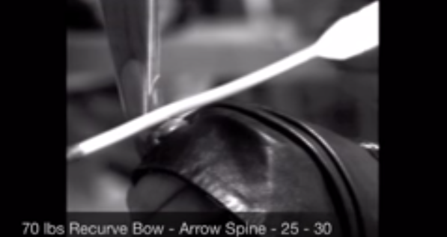
Video 1: Wooden arrow with incorrect spine shattering upon shooting. Carbon fiber arrows splintering are even more terrifying and can lead to horrific puncture injuries. [Embed: https://youtu.be/96KGWC0PB6s?t=378]

Properly matching arrows to the bow is particularly critical for accuracy in recurve and longbows. For those bows, the arrow has to curve around the riser/bow because of something called the archer’s paradox. You can restart the video above from the beginning to see it in action. Too stiff an arrow and it will fly off to the left because it’s not flexible enough to bend back around the bow towards your point of aim. With too high a spine, the arrow will bend around too much and land to the right of your point of aim.

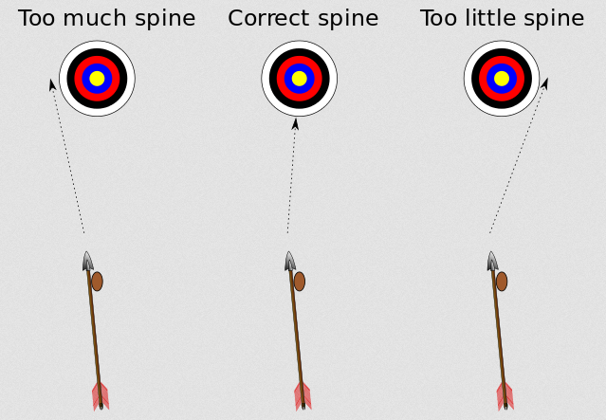
Image 1: Effect of spine on point of impact. Courtesy of MyArcheryCorner.com
[https://www.myarcherycorner.com/wp-content/uploads/2015/10/correct-spine.png]

When being shot, how stiff the arrow acts is called dynamic spine, and it can be dramatically different from the static spine rating. For example, heavier points or longer shafts than what is needed will make the arrow act as if it has a higher spine than the actual rating, meaning it will ‘flex’ more. This makes intuitive sense as there is more inertia before it starts moving in the case of a heavier point; in the second case, it’s easier to get more leverage to bend a long stick as opposed to a short one. Relating all this all back to draw distance, if an archer doesn’t draw back the bow as much as they normally do because of not using a consistent anchor, they will have less energy in the shot, and the arrow will act as if it’s a stiffer arrow than it actually is. For that shot, in addition to dropping more than the shot would normally, it will also start landing left of the point of aim.

The Effect of Draw Distance
How much of a difference does the draw distance really matter? The primary effect is a change in the draw weight and what that does to the shot. First, let’s look at the change in the draw weight. Every bow (and type of bow) loads the draw weight differently at different distances, but generally, people will say an inch of draw distance will change the draw weight by a pound or two. I measured the draw weight at different points with a 35lb Samick Sage recurve and averaged a dozen pulls. You can see that the difference in draw weight for the inch between 25 and 26 is almost double the draw weight increase for the inch between 24 and 25:
Draw Distance (inches) | Draw Weight (in lbs) | Change per inch (in lbs)
28 | 35 | +3.2
26.25 | 29.5 | +2.6
25.25 | 26.9 | +1.4
24.25 | 25.5
Chart 1: Draw distance vs Draw weight for Samick Sage Recurve with 35# @28” limbs. Note the further the bow is drawn, the higher the draw weight difference per inch.
Next, let’s look at the effect of draw weight pushing the arrow. The change in draw weight will reduce the FPS, and there is ample documentation on the effect of even a single FPS variance out to the 70 meter USAA shooting distance. At 70m it’s 6.4cm of vertical drop per FPS variation, which is enough to be a whole point different for each fps difference between shots.
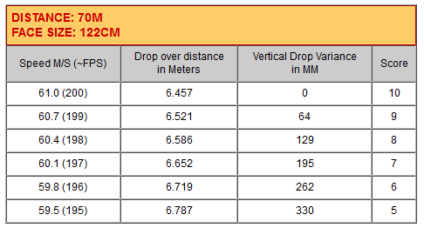
Chart 2: The vertical drop of point of impact vs point of aim per FPS. Courtesy of KSL Archery. [http://www.kslinternationalarchery.com/Equipment/ArrowSpeed.html ].
It should be noted that, in researching this article, draw distance variability in Olympic and World competition archers are in the range of millimeters, and even then, there is a measurable correlation to lower scores for those with higher variation. To illustrate the effects of draw distance in a more typical beginner situation, I performed some non-rigorous testing with the same 35# Sage recurve. I tested the difference in draw distance of just an inch, 26.25 down to 25.25, for a few dozen shots at the indoor 18 meter distance and it showed an arrow drop of roughly 6 inches. We also saw the grouping shift slightly from around the center line to just left of the center line, suggesting that the dynamic spine was changing as well. Though an inch is significant for an experienced archer, I see this amount of variation often with my beginners that are still trying to figure out their anchors, floating their hand, or lightly touching their face versus pressing their draw hand to their anchor point.

Dialing in Draw Distance
Now that we understand the effects of over or under drawing, how do we work to minimize the variation? From a high level perspective, it all falls into the general category of ‘form,’ but leaving it at that is not particularly helpful, so we’ll review all the sources of variation from one end of the archer’s draw to the other. Before we hit the list, I want to point out that it really helps to have an experienced archer or coach be an extra set of eyes, and lend the voice of experience. Another option would be using a tripod with a phone or tablet and an app like “Coach’s Eye,” if you are trying to do this solo. What proper posture will look like will vary by style and coach, so be sure to ask for help when you need it. What I always tell my students is, “When in doubt, experiment.” Shoot a range of distances, not just your usual distances. You may find that after a few hundred shots that the change does make a significant difference at your longest distances, even if the effect is very small or not evident at your comfortable distances.

What affects draw distance?
- Bow arm position: Generally, you will want a slight bend in the elbow and not have it “locked out,” which often results in string slap. Try to make sure you have the same arm position every time.
- Bow hand position: Having your hand in more of a “stop” hand position will have the bow pressing against your palm, which will vary less than a “point” hand position where the bow rests against the webbing between your thumb and pointer finger. Having a relaxed grip will also reduce variability compared to a death grip. Studies show that a death grip also negatively affects how the arrow clears the bow during a shot.
- Shoulder position: Relax your shoulders. I’ve seen beginners with their shoulders tensed almost up to their ears. This means as they tire during a shoot, they can’t hold that unnatural and uncomfortable position and their shots get more wild. Some archery styles suggest having the shoulders pressed outwards fully against the pressure of the drawn bow.
- Draw hand: The most obvious suggestion here is finding a good solid anchor point somewhere on the head or face. Don’t “float” it near the face, instead have some part of your hand pressed to your anchor point.
- Draw hand position: Studies suggest that at the highest levels of competition, the left-right variation during release does not affect the accuracy very much, but then again the “variation” at the Olympic level is in the range of millimeters. I’m sure we’ve all seen the effects of beginners “plucking” the bow string on release. I suggest my beginners have the string sitting along the first knuckle of the finger back from the fingertip, or on the fingertips, and try for a straight line from elbow through the wrist and across the hand. Don’t hold the string in a fist like a hammer grip, or “curl” the hand.
- Head position: The archer should hold their head in a natural position. Don’t crane your neck in awkward positions.
- Breath: Just like in firearms practice, notice your chest position and how much it can vary at full draw. Compare it at a full breath or fully exhaled, make sure you are at the same breath level each shot. Make it part of your shot cycle.
- Posture on full draw: Don’t slump or slouch, and on the other extreme, don’t stick your chest out in an exaggerated way.
- Clickers: Olympic recurve bows are often fitted with an attachment called a clicker that helps make the draw distance more consistent. Proper use of these is important; the “final pull” should be smooth and consistent, with a quick reaction to release the string once it clicks. If the reaction time is poor, we’d be in the same situation as before with inconsistent draw distances. Multiple studies reinforce that fast clicker reaction time is highly correlated to better archery performance.

A step towards mastery
Archery is immensely challenging and that draws many people to the sport. It involves entire systems of physiology, physics and psychology. We’ve reviewed the effect of draw distance and the impact it has on our shooting. We then covered a number of the most common sources of variability. Hopefully, this review has improved your understanding of the dynamics involved and given you some ideas to work on at your next shooting session. Archery, like any deep skill, is a journey. There are no silver bullets, no single trick that will turn a beginner into an Olympian. Skill comes from dedicated and mindful practice. It comes from reading, learning, and practicing one skill at a time, or as some archery clubs say, one arrow at a time.

[NOTE to Professor: I am not including a bibliography because after asking several authors, I found that they are not normal for inclusion for magazine submissions, but the sources are the same as noted in the synthesis. I still intend to try for an academic paper with proper IRB research measurement once class time constraints are not a factor.]

